# CS 255 System Design Document Template

This template lays out all the different sections that you need to complete for Project Two. Each section has guidance to prompt your thinking. You will need to continually reference the interview transcript as you work to make sure that you are addressing your client’s needs. There is no required length for the final document. Instead, the goal is to complete each section based on what your client’s needs are. Remove this note when you are finished, and replace all bracketed text with the relevant information.

## UML Diagrams

### UML Use Case Diagram

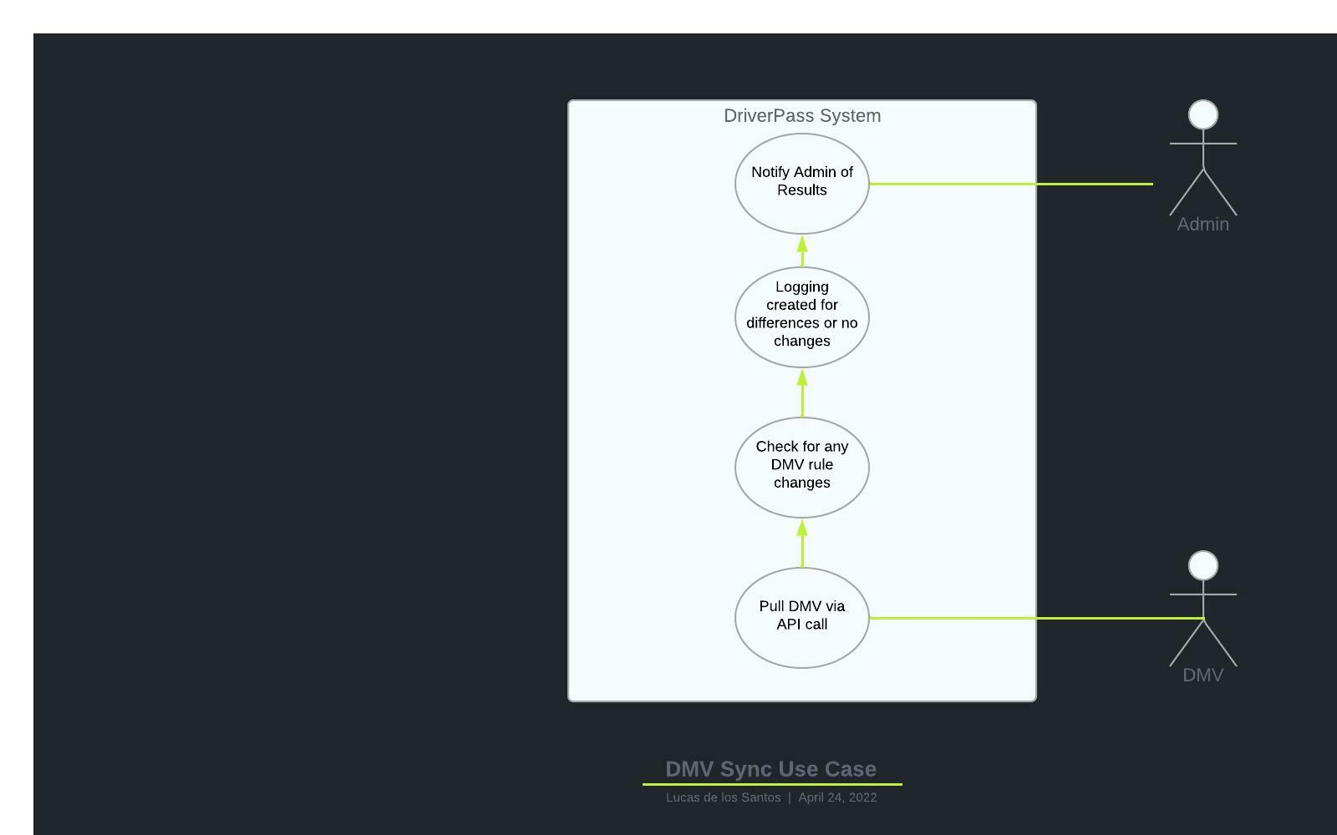

### UML Activity Diagrams

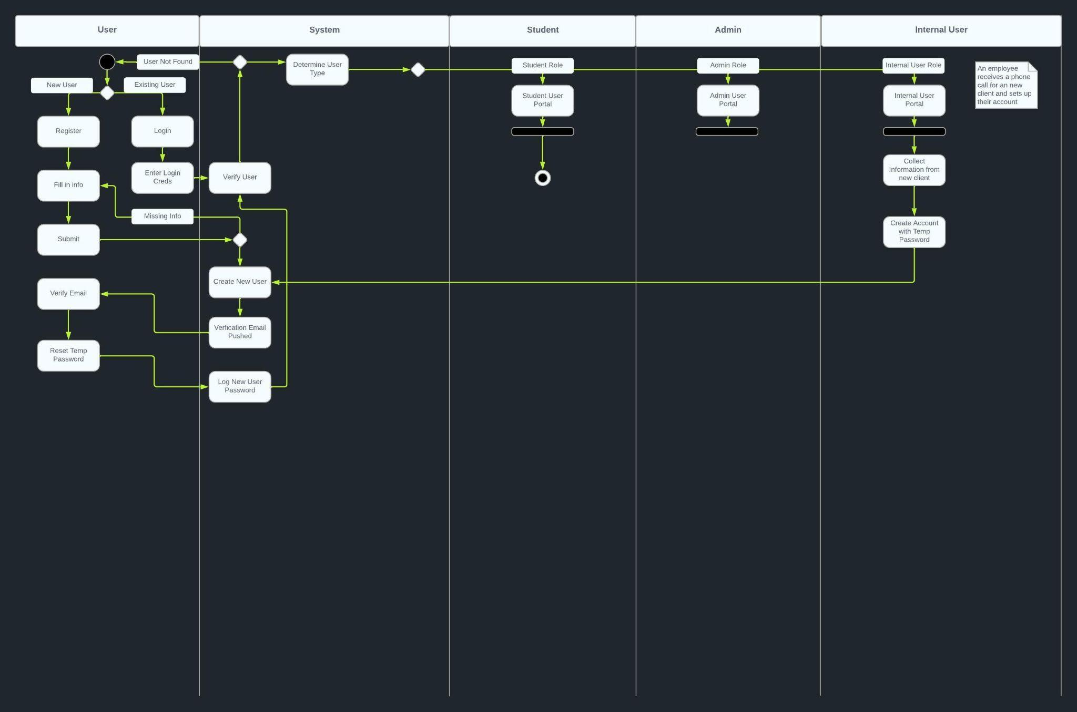

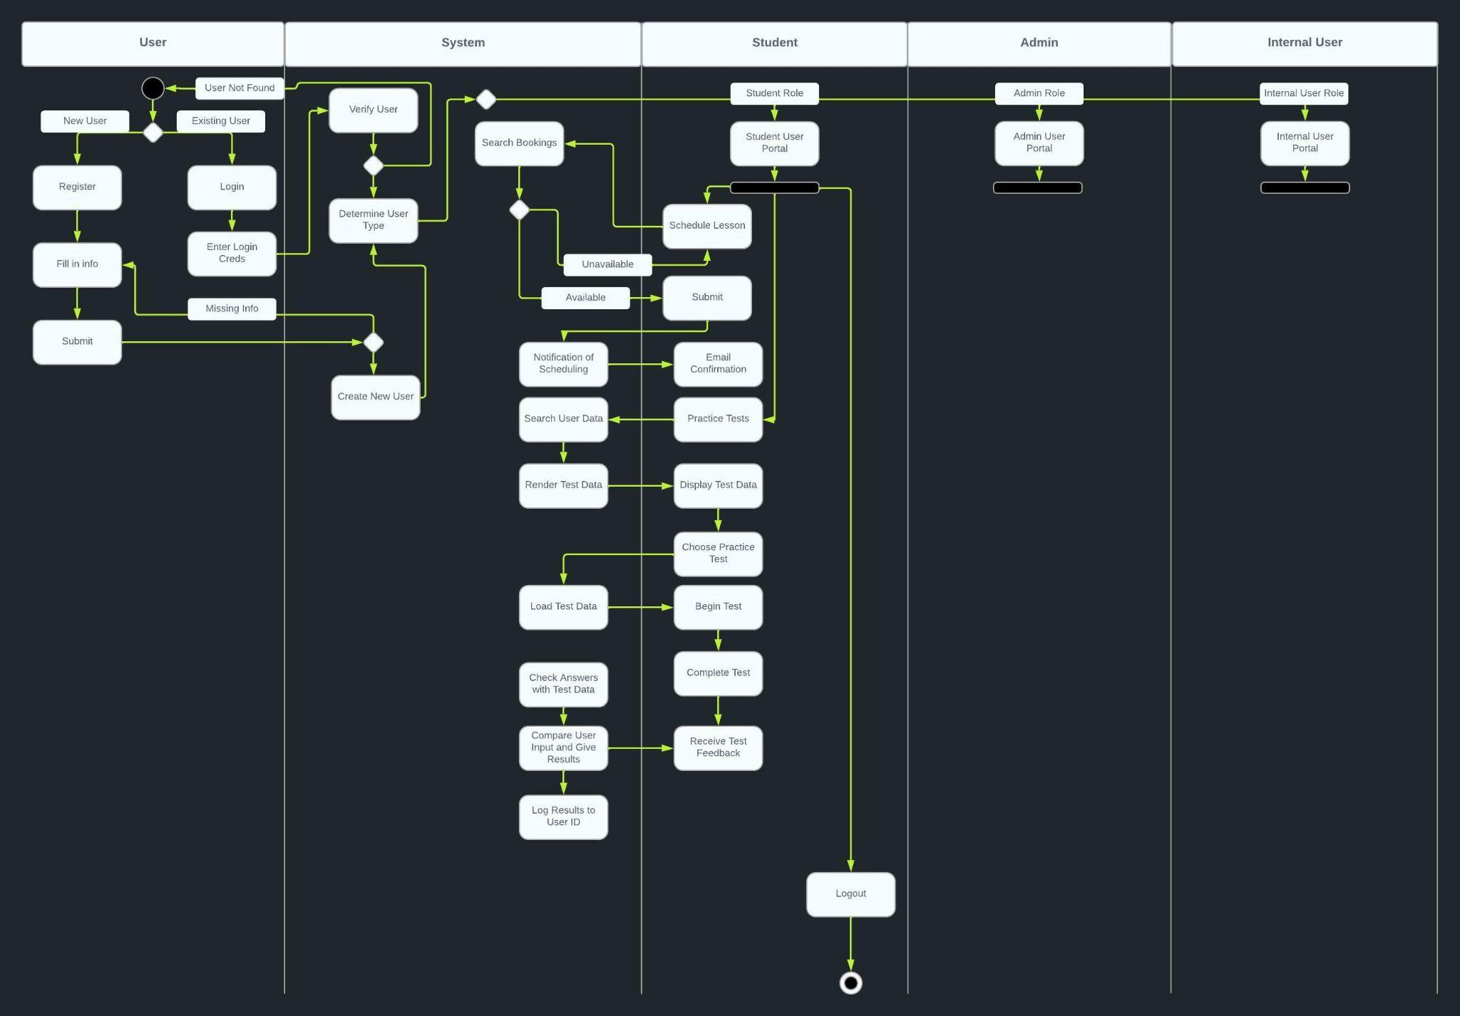

### UML Sequence Diagram

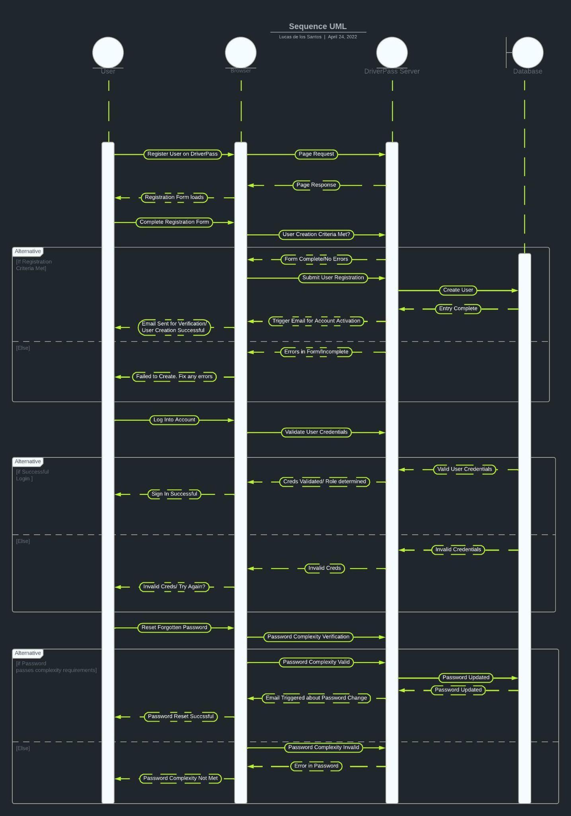

### UML Class Diagram

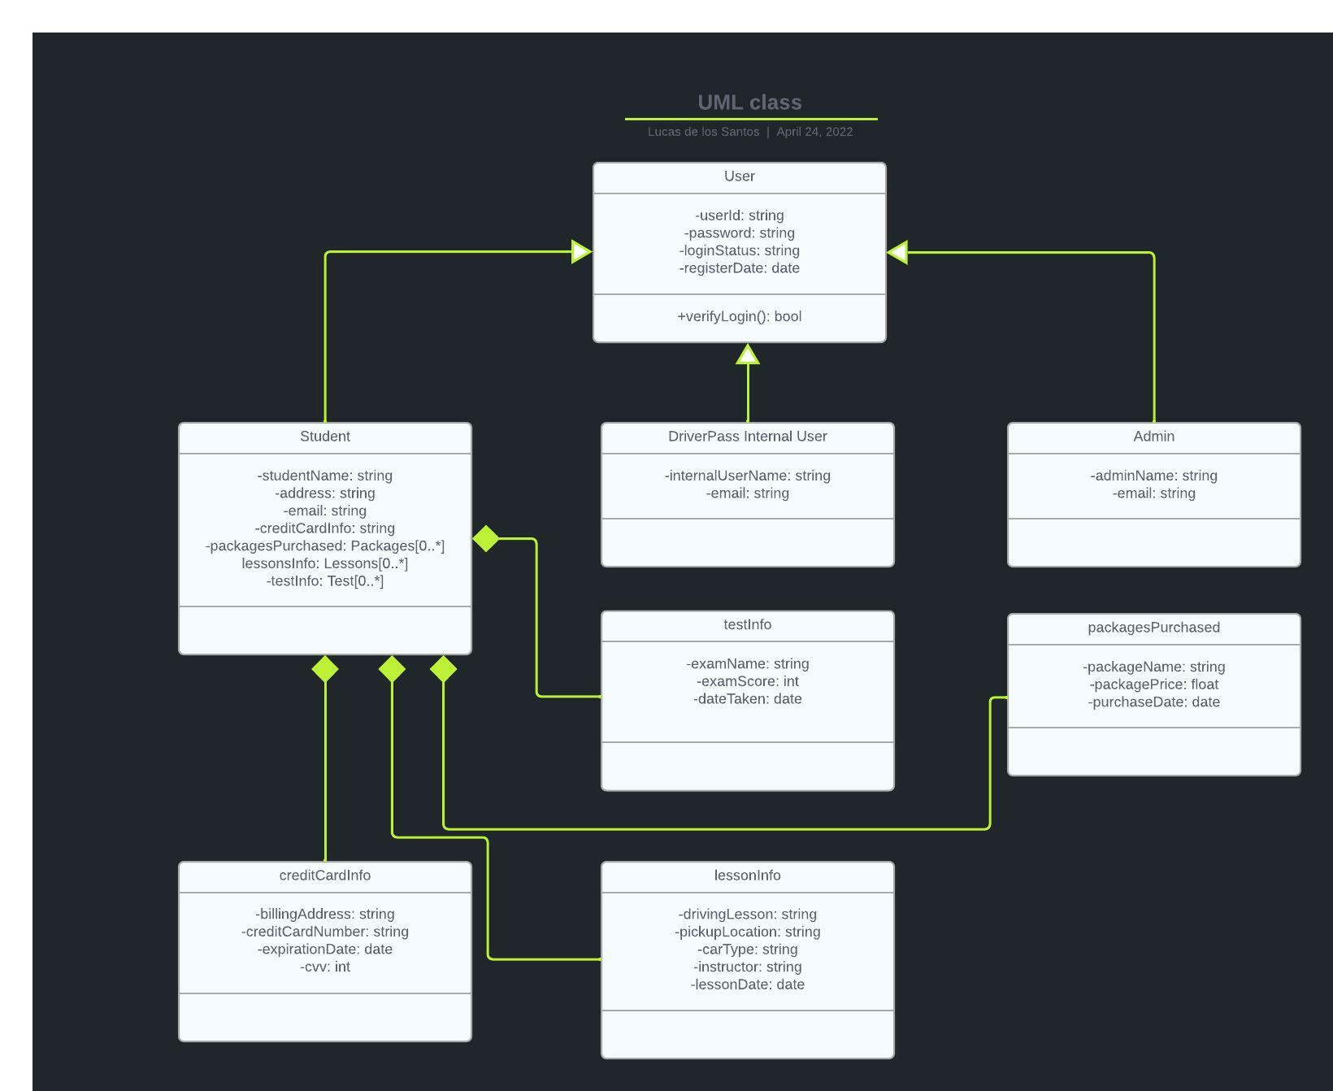

## Technical Requirements

* Linux based backend (Cloud Agnostic)
  + Preferably containerized cluster using Kubernetes with a persistent drive for the database.
  + PCI compliant database
  + Apache or NGINX front end/load balancer in an auto-scaling group
  + Multiple environments for moving product from Alpha to Release.
    - Dev(Sandbox)
    - QA
    - Stage
    - Prod
  + Intrusion detection system for sensitive data areas
  + Encryption in deployment(SSL)
* Automation
  + Terraform for Infra build out
  + Integration, Smoke, Unit, Load, and Performance Testing (Jmeter, Cucumber, Sonarqube, etc)
  + CI/CD pipeline for managing new code updates (Jenkins, ArgoCD, CodeBuild,etc)
* Browser Support Matrix
  + Determine and plan for as many browsers available with backward compatibility for older browsers
  + Optimize code for both desktop and mobile browsers
  + Works with all modern-day web browsers